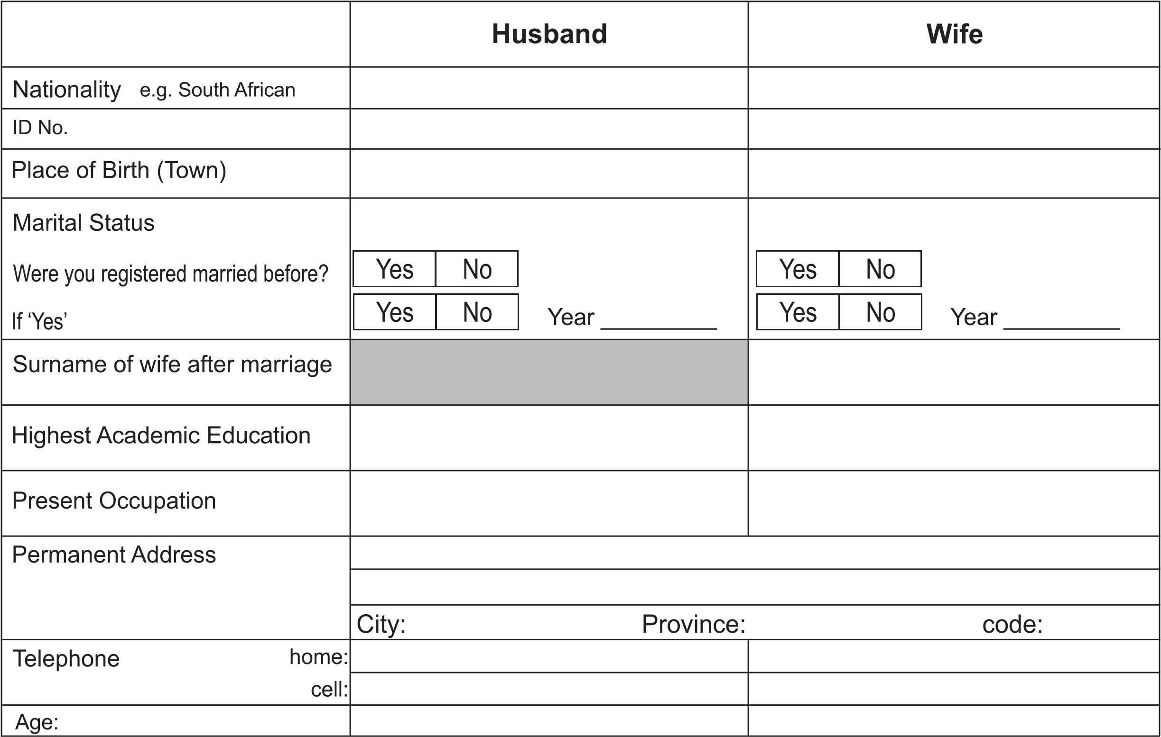

## Step 1: Fill in the Marriage Registration Details form and submit it along with ID copies of both spouses to [kathrada.a@darulihsan.com](mailto:kathrada.a@darulihsan.com) . After submission, contact Ml A Kathrada at 031 5777 868 / 083 500 7868 to schedule an appointment for the Marriage Registration.

**Step Two:** On the day of the ‘Marriage Registration’ both spouses must be present along with:

* Original ID books & copies (one per spouse)
* Three passport-size colour photos of each spouse
* Two copies of the ‘Ante Nuptial Contract’ (First page where the protocol number appears)

**Important Notes**

* Muslims couples are advised to draw-up an ‘Ante Nuptial Contract’ - excluding the accrual system - with an attorney
* If either spouses were previously married (**registered marriage only**), a copy of the ‘**Decree of Divorce’** is required
* All marriage registrations take place at Darul Ihsan Humanitarian Centre (DHC), 70 Joyce Road, Sea Cow Lake, Durban

**Please note that any personal information submitted to us will be collected, processed, and stored as is necessary to carry out actions for the conclusion or performance of the agreement entered into between the parties in accordance with the Protection of Personal Information Act.**

I hereby grant my consent that the personal information hereby provided by either myself (the client) or any third party may be used and processed as is necessary to carry out actions and functions for the conclusion or performance of the agreement entered into between the parties.